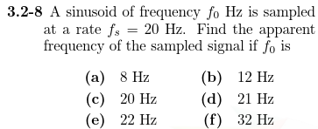

Using MATLAB we can see that the apparent frequency of a signal with frequency $f_{0}$ sampled at $f_{s}=20Hz$

is: $f_{apparent}=\frac{f_{0}*f_{s}}{LCM}$ where LCM is the Least Common Multiple between the two frequencies

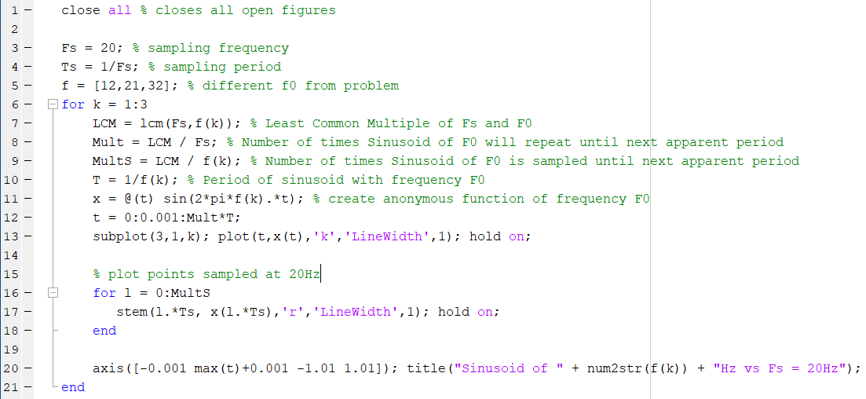

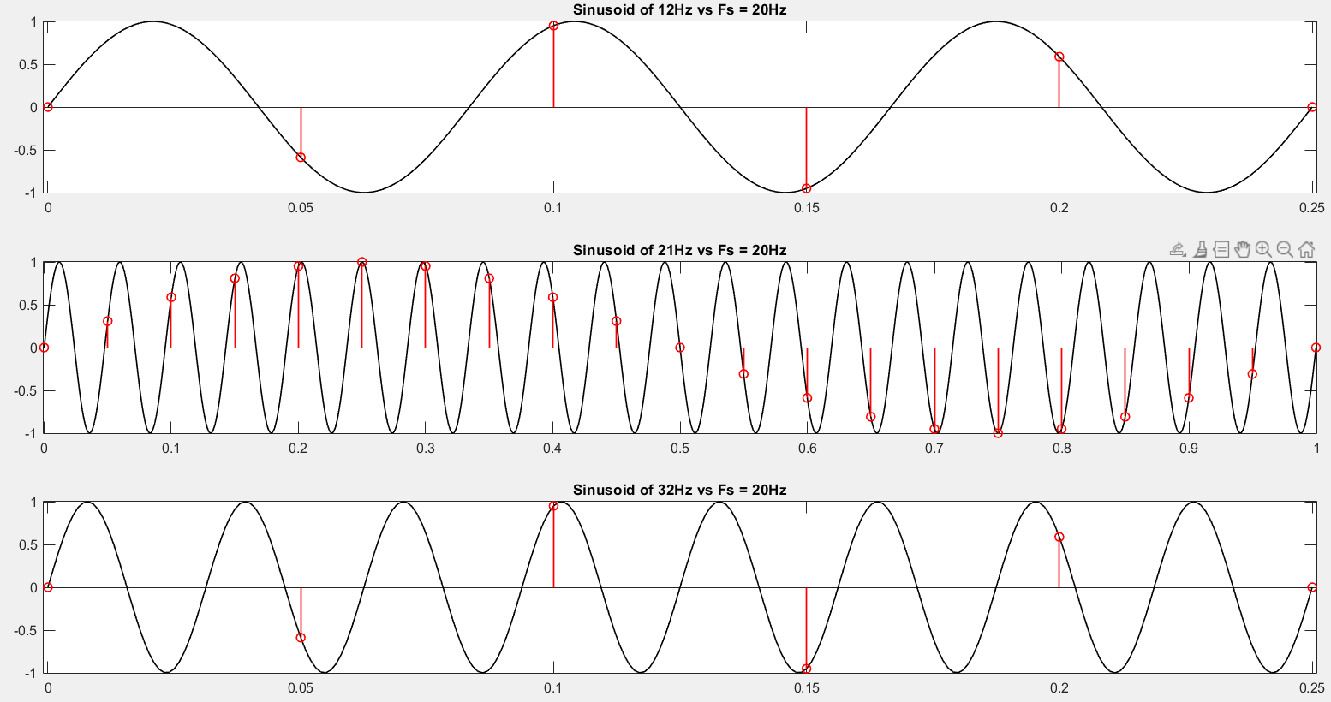

Or:

b) $LCM\left(20Hz,12Hz\right)=60Hz$ $f_{apparent}=\frac{12*20}{60}=4Hz$

d) $LCM\left(20Hz,21Hz\right)=420Hz$ $f_{apparent}=\frac{21*20}{420}=1Hz$

f) $LCM\left(20Hz,32Hz\right)=160Hz$ $f_{apparent}=\frac{32*20}{160}=4Hz$

We can see this a little more clearly (especially for part d) if we repeat this new “apparent frequency” signal five times

